

MANGU 2025 KCSE PREDICTION
CONFIDENTIAL EXAM
233/1
CHEMISTRY
PAPER 1 (THEORY)
TIME: 2 HOURS

NAME……………………………………………………………………………………….
SCHOOL……………………………………………… SIGN………………………..
INDEX NO……………………………………………. ADM NO……………………

(Kenya Certificate of Secondary Education)

INSTRUCTIONS TO CANDIDATES
- Write your name, admission number, class, date and then sign in the spaces provided.
- Answer all questions in the spaces provided.
- KNEC mathematical tables and silent electronic calculators may be used for calculations.
- All workings must be clearly shown where necessary.

For Examiners Use Only
QUESTIONS | MAXIMUM SCORE | STUDENTS SCORE
1-29 | 80

1. When magnesium metal is burnt in air, a white ash is formed. Write the formula of the two components of the white ash. (2marks)
…………………………………………………………………………………………………………
…………………………………………………………………………………………………………
…………………………………………………………………………………………………………

2. What type of bond is formed when sodium and chlorine react? Explain. (2marks)
(Atomic numbers: Na = 11 and Cl = 17)
…………………………………………………………………………………………………………
…………………………………………………………………………………………………………
…………………………………………………………………………………………………………
…………………………………………………………………………………………………………

3. When solid Sodium carbonate was added to a solution of hydrogen chloride in methylbenzene, there was no apparent reaction. On addition of water to the resulting mixture, there was vigorous effervescence. Explain these observations. (3marks)
…………………………………………………………………………………………………………
…………………………………………………………………………………………………………
…………………………………………………………………………………………………………
…………………………………………………………………………………………………………
…………………………………………………………………………………………………………

4. Below is a simplified scheme of Solvay process. Study it and answer the questions that follow:
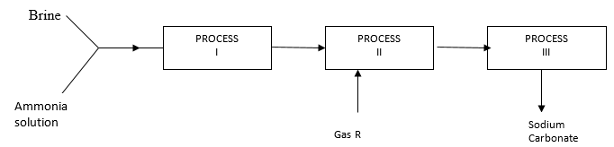
a) Identify gas R. (1mark)
................................................................................

b) Write an equation for the process III. (1mark)
…………………………………………………………………………………………………………

c) Give two use of sodium carbonate. (1mark)
…………………………………………………………………………………………………………
…………………………………………………………………………………………………………

5. When potassium nitrate is heated, it produces potassium nitrite and gas C.
(a) Identify gas C (1mark)
…………………………………………………………………………………………………………

(b) Name the type of reaction undergone by the potassium nitrate (1mark)
…………………………………………………………………………………………………………

6. When a few drops of aqueous ammonia were added to copper (II) nitrate solution, a light blue precipitate was formed. On addition of more aqueous ammonia, a deep blue solution was formed.
Identify the substance responsible for the:
  - Light blue precipitate. (1mark)
…………………………………………………………………………………………………………

  - Deep blue solution. (1mark)
…………………………………………………………………………………………………………

7. The first step in the industrial manufacture of nitric (v) acid is the catalytic oxidation of ammonia gas.
(a) What is the name of the catalyst used? (1 mark)
…………………………………………………………………………………………………………
(b) Write the equation for the catalytic oxidation of ammonia gas. (1mark)
…………………………………………………………………………………………………………
…………………………………………………………………………………………………………

(c) Nitric acid is used to manufacture ammonium nitrate, state two uses of ammonium nitrate.
(1mark)
…………………………………………………………………………………………………………
…………………………………………………………………………………………………………

8. a) Complete the table below to show the colour of the given indicator in. (1mark)
Indicator | Colour in
 | Acid solution | Basic solution
Methyl orange | ……………. | Yellow
Phenolphthalein | Colorless | ………………
b) How does the pH value of 0.1 M potassium hydroxide solution compare with that of 0.1M aqueous ammonia? Explain. (2marks)
…………………………………………………………………………………………………………
…………………………………………………………………………………………………………
…………………………………………………………………………………………………………
…………………………………………………………………………………………………………

9. Sketch and label a graph to show activation energy in an endothermic reaction. (3marks)

10. The graph below shows a curve obtained when water at 20ºC was heated for 15 minutes.
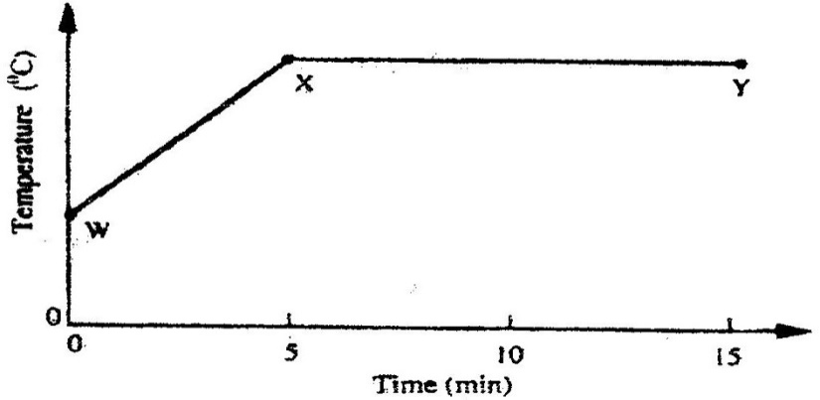
a) What happens to the water molecules between points W and x? (1mark)
…………………………………………………………………………………………………………
…………………………………………………………………………………………………………
b) In which part of the curve does a change of state occur? (1mark)
…………………………………………………………………………………………………………
c) State one application of the effect of impurities on melting point of substances. (1mark)
…………………………………………………………………………………………………………
…………………………………………………………………………………………………………

11.In an experiment, magnesium reacted with copper (ii) sulphate solution.
a) What type of reaction is illustrated. (1mark)
…………………………………………………………………………………………………………
b) state two observations made. (2marks)
…………………………………………………………………………………………………………
…………………………………………………………………………………………………………
…………………………………………………………………………………………………………

12. 15.0cm³ of ethanoic acid (CH₃COOH) was dissolved in water to make 500cm³ of solution. Calculate the concentration of the solution in moles per litre. (C=12.0; H=1.0; O=16.0; density of ethanoic acid is 1.05 g/cm³). (3marks)
…………………………………………………………………………………………………………
…………………………………………………………………………………………………………
…………………………………………………………………………………………………………
…………………………………………………………………………………………………………
…………………………………………………………………………………………………………

13. In an experiment, a few drops of concentrated nitric (v) acid were added to aqueous iron (II) sulphate in a test tube. Excess sodium hydroxide solution was then added to the mixture.
a) State the observations that were made when:
i)Concentrated nitric (v) acid was added to aqueous iron (II) sulphate. (1mark)
…………………………………………………………………………………………………………

ii) Excess sodium hydroxide was added to the mixture. (1mark)
…………………………………………………………………………………………………………

b) Write the ionic equation for the reaction which occurred in (a) (ii) above. (1mark)
…………………………………………………………………………………………………………
…………………………………………………………………………………………………………

14.The set-up below was used to collect a dry sample of a gas.
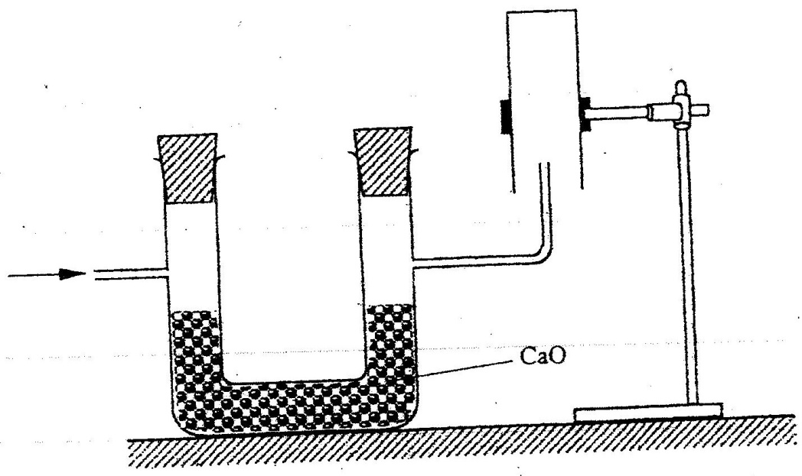
a) Give two reasons why the set-up cannot be used to collect carbon (iv) oxide gas. (2marks)
…………………………………………………………………………………………………………
…………………………………………………………………………………………………………
…………………………………………………………………………………………………………

b) Name a gas that can be collected by the above set up. (1mark)
…………………………………………………………………………………………………………

15 The basic raw material for extraction of aluminium is bauxite
a) Name the method that is used to extract aluminium from bauxite. (1mark)
…………………………………………………………………………………………………………
b) Write the chemical formula of the major component of bauxite. (1mark)
…………………………………………………………………………………………………………
c) Name two major impurities in bauxite. (1mark)
…………………………………………………………………………………………………………
…………………………………………………………………………………………………………

16. During the electrolysis of aqueous silver nitrate, a current of 5.0A was passed through the electrolysis for 3 hours.
a) Write the equation for reaction which took place at the cathode. (1mark)
…………………………………………………………………………………………………………
…………………………………………………………………………………………………………

b) Calculate the mass of silver deposited at the cathode. (Ag = 108; IF=96500C). (2marks)
…………………………………………………………………………………………………………
…………………………………………………………………………………………………………
…………………………………………………………………………………………………………
…………………………………………………………………………………………………………

17. A compound whose general formula is M (OH)₃ reacts as shown by the equation below.
M (OH) _{3(s)} + OH _{(aq)} M (OH) _{4(aq)}
M (OH) _{3(s)} + 3H⁺ _{(aq)} M³⁺ _{(aq)} + 3H₂O _{(i)}
(a) What name is given to compounds which behave like M (OH) ₃ in the two
Reactions (1 mark)
…………………………………………………………………………………………………………

(b) Name two elements whose hydroxides behave like that of M (2 marks)
…………………………………………………………………………………………………………
…………………………………………………………………………………………………………
18. a) State the Graham’s law of diffusion. (1mark)
…………………………………………………………………………………………………………
…………………………………………………………………………………………………………

b) The molar masses of gases W and X are 16.0 and 44.0 respectively. If the rate of diffusion of W through a porous material is 12cm³s⁻¹, calculate the rate of diffusion of X through the same material. (2marks)
…………………………………………………………………………………………………………
…………………………………………………………………………………………………………
…………………………………………………………………………………………………………
…………………………………………………………………………………………………………

19. In a closed system, aqueous iron (III) chloride reacts with sulphide gas as shown in the equation below.
State and explain the effects on the position of equilibrium point when dilute hydrochloric acid is added to the system at equilibrium. (2marks)
…………………………………………………………………………………………………………
…………………………………………………………………………………………………………
…………………………………………………………………………………………………………
…………………………………………………………………………………………………………

20.In an experiment to determine the percentage of magnesium hydroxide in an anti-acid, a solution containing 0.50 g of the anti-acid was neutralized by 23.0 cm³ of 0.1M hydrochloric acid (Relative formula mass of magnesium hydroxide =58)
Determine the,
a) Mass of magnesium hydroxide in the anti-acid. (2marks)
…………………………………………………………………………………………………………
…………………………………………………………………………………………………………
…………………………………………………………………………………………………………
…………………………………………………………………………………………………………

b) Percentage of magnesium hydroxide in the anti-acid . (1mark)
…………………………………………………………………………………………………………
…………………………………………………………………………………………………………
…………………………………………………………………………………………………………

21. Study the flow chart below and answer the questions that follow.
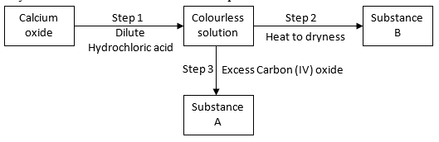
a) Give the name of the process that takes place in step 1. (1mark)
…………………………………………………………………………………………………………

b) Give;
(i) The name of substance A. (1mark)
………………………………………………………………………………………

(ii) One use of substance B. (1mark)
…………………………………………………………………………………………………………

22. Starting with 50 cm³ of 2.8M sodium hydroxide, describe how a sample of pure sodium sulphate crystals can be prepared. (3 marks)
…………………………………………………………………………………………………………
…………………………………………………………………………………………………………
…………………………………………………………………………………………………………
…………………………………………………………………………………………………………
…………………………………………………………………………………………………………
…………………………………………………………………………………………………………

23. Use the information below to answer the questions that follow:
Equation Enthalpy of formation
H₂ (g) + ½ O₂ (g) H₂O (l) H= -286 kjmol⁻¹
C(s) + O₂ (g) CO₂ (g) H= -394kjmol⁻¹
2C(s) + 3H₂ (g) + ½ O₂ C₂H₅OH (i); H=277kjmol⁻¹

- Define the term “enthalpy of formation of a compound (1mark)
…………………………………………………………………………………………………………
…………………………………………………………………………………………………………

b) Calculate the molar enthalpy of combustion, H_{c} of ethanol:
C₂H₅OH (l) + 3O₂(g) 2CO₂ (g) +3H₂O (l) (2mks)
…………………………………………………………………………………………………………
…………………………………………………………………………………………………………
…………………………………………………………………………………………………………
…………………………………………………………………………………………………………

24. A student set up the experiment below to collect gas K, the glass wool was heated before heating the Zinc powder.
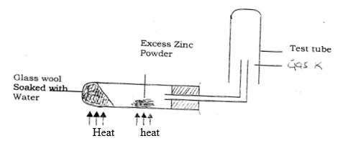
a) Explain why was it necessary to heat the moist glass wool before heating zinc powder. (2marks)
…………………………………………………………………………………………………………
…………………………………………………………………………………………………………
…………………………………………………………………………………………………………

b) Identify gas K. (1mark)
…………………………………………………………………………………………………………

25. Compound W (not its actual symbol) is a solid with a giant ionic structure. In what form would the compound conduct an electric current, explain. (2marks)
…………………………………………………………………………………………………………
…………………………………………………………………………………………………………
…………………………………………………………………………………………………………

26.Pentane and ethanol are miscible. Describe how water could be used to separate a mixture of pentane and ethanol. (3marks)
…………………………………………………………………………………………………………
…………………………………………………………………………………………………………
…………………………………………………………………………………………………………
…………………………………………………………………………………………………………

27. But -2- ene undergoes hydrogenation according to the equation given below
CH₃CH = CHCH₃ (g) + H₂ (g) →CH₃CH₂CH₂CH₃ (g)
(a) Name the product formed when but -2 – ene reacts with hydrogen gas. (1mark)
………………………………………………………………………………………………
(b) State one industrial use of hydrogenation. (1mark)
………………………………………………………………………………………………

28. The figure below shows the behaviour of emissions by a radioactive isotope x. Use it to answer the question follow
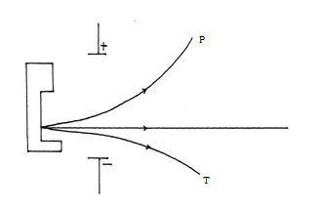

(a) Why does isotope X emits radiations. (1mark)
…………………………………………………………………………………………………………
…………………………………………………………………………………………………………

(b) Name the radiation labelled T (1mark)
…………………………………………………………………………………………………………

c) What is half-life (1mark)
…………………………………………………………………………………………………………
…………………………………………………………………………………………………………

29.a) State two reasons why cars are painted (1mark)
…………………………………………………………………………………………………………
…………………………………………………………………………………………………………
…………………………………………………………………………………………………………
…………………………………………………………………………………………………………

b) Explain why electric cars are better than ordinary fuel cars. (2marks)
…………………………………………………………………………………………………………
…………………………………………………………………………………………………………
…………………………………………………………………………………………………………
…………………………………………………………………………………………………………

THIS IS THE LAST PRINTED PAGE

